

REsidential lease packet

This Residential Lease Packet Agreement has not been approved by the Colorado Real Estate Commission. This form was prepared in November of 2021 by the law firm of Gelman & Norberg, LLC, as legal counsel for Manager, and may not be altered other than by completing any blank spaces in the form.

In this Lease, the following terms apply:
Description of Property (“Property”):
Lease Start Date:
Lease End Date:
Monthly Rent:
Security Deposit:
Property Manager (“Manager”):
Manager’s Address:
Manager’s Phone Number:
Are Pets Authorized? | Yes No
Utilities/Services Paid by Tenant:
Utilities/Services Paid by Manager:
Maximum Number of Vehicles:
Tenant Does Yard Care & Snow Removal? | Yes No
Smoking Permitted Inside Structures? | Yes No

- TERM. The term of this Lease shall be for the period shown at the top of this Lease. Tenant may not remain on Property past the Lease End Date. Tenant will be informed prior to Lease End Date whether the option to sign another Lease term exists, which may be provided by Manager in Manager’s sole and absolute discretion. If Tenant desires to terminate the Lease before the Lease End Date, Tenant must give a minimum of 60 days’ written notice to Manager and pay an Early Termination fee equal to two months’ rent. The Early Termination Fee may not be paid in part or whole by Tenant’s Security Deposit. The Early Termination Fee must be paid at least 30 days prior to the agreed upon Early Termination date. If Tenant fails to pay Early Termination Fee by this date, the Lease remains in full force and effect for the original Lease term.

- RENT. Rent shall be made payable to Manager, monthly, in advance, to be received no later than the 1st day of the month by Manager. There is no grace period. Any rent payment that is not timely remitted will accrue a late charge of 5% of the balance due. Payment shall be made on Manager’s online Tenant Portal via Electronic Funds Transfer (EFT) or credit card. No other payment forms are accepted. Tenant acknowledges there is a convenience fee charged for each EFT payment, and service and/or convenience fee for credit card payments. If Tenant fails to make payment of rent by the first day of any month, Tenant will be in default and Manager will be entitled, at its sole option, to pursue any and all remedies for default available under this Lease or by law. Manager, in its sole discretion, may or may not elect to accept late rent payment, including the late fee of 5%, as identified above. Tenant acknowledges that late rent payments may result in termination of the lease, eviction, and/or a charge against security deposit funds. If Management Agreement is cancelled between Owner and Manager, this lease remains in effect and Owner and Tenant will agree on a form of rent payment. The payment of rent and any other amounts owed pursuant to this Lease is a separate and independent obligation of any other obligation under this Lease. Tenant has no right to offset or refuse to pay rent and any other amounts owed pursuant to this Lease as a result of any claimed breach of this Lease by Manager or Owner.

- SECURITY DEPOSIT. At the time of signing of this Lease, Tenant must deposit with Manager the Security Deposit, which Manager will hold as security for the full and faithful performance by Tenant of all promises, conditions, and agreements in this Lease. Manager shall not be required to apply the Security Deposit to any charges or damages for Tenant's failure to perform the promises and agreements of this Lease but may do so at Manager’s option. Manager's right to possession of the Property for non-payment of rent or for any other reason will not be limited by Manager's holding of the Security Deposit. The Security Deposit or any portion thereof which is not applied toward the payment of rent, damages, repairs, utilities, or costs, including attorney's fees or any other amounts permitted under this Lease or by law, will be returned to Tenant whose name and address are listed first at the top of this Lease, without interest within 60 days after termination of this Lease or surrender and acceptance of the Property, whichever occurs later. In the event Manager retains a portion of the Security Deposit, Manager shall provide Tenant with a detailed accounting of the amounts withheld and for what purposes. Holding or applying the Security Deposit does not limit Manager's right to exercise all remedies under this Lease or as provided by law, nor is Manager's recovery of damages limited to the amount of the Security Deposit. The Security Deposit may, at Manager's election, be used at any time during the Lease period to repair, clean, or replace any damage to the Property or fixtures caused by Tenant. If Manager elects to expend any such funds from the Security Deposit then Tenant must immediately bring the Security Deposit up to the stated amount upon presentation by Manager of a receipt, bill or other evidence of the reasonable charges and costs in connection with such repair, cleaning or replacement. At Manager’s sole discretion, the Security Deposit may be used to pay unpaid rent and other amounts owed pursuant to this Lease, including but not limited to in the event Tenant ceases making rent payments or attempts to terminate this Lease in any manner other than as is set forth in paragraph 1, above. Manager will not make partial refunds of deposits when one party of a joint and several lease vacates the Property. In that instance, the entire Security Deposit amount will remain on hand in Manager’s deposit escrow account until all parties of a joint and several lease vacate the Property.

- CONDITION OF PROPERTY UPON MOVE-IN. Tenant has examined and accepts the Property in its “as is” condition as of the Lease Start Date, and waives all claims for defects or otherwise, except as specifically noted in an inspection addendum e-mailed to Manager by Tenant, which must be returned by Tenant to Manager no later than 7 days from the Lease Start Date. Such “inspection addendum” shall consist of a detailed description of the existing problem(s), including its exact location within the Property, along with photos. Failure by Tenant to provide an inspection addendum within 7 days of the Lease Start Date shall be deemed to be conclusive and binding on the Tenant that the Property is in acceptable and professionally clean condition (including all appliances, plumbing fixtures and shelving) and free from all defects at the time of the Lease Start Date. Tenant has examined and accepts the condition of all appliances, carpeting, fixtures and furnishings, if any, in the Property, with the exception of all items noted in the inspection addendum. Tenant acknowledges that all light bulbs are working and will be replaced as needed at Tenant’s expense through the termination of this Lease. Any damage to the Property not specifically listed on the inspection addendum will be repaired at Tenant’s expense.

- CARE OF PROPERTY & CONDITION UPON TERMINATION.

A. Tenant agrees to keep the Property, the improvements, all fixtures, doors, glass, windows, carpeting, outdoor areas such as the lawn, plumbing and appliances in good repair, normal wear and tear excepted, throughout the term of this Lease. Any malfunction of any item due to normal wear and tear will be replaced or repaired at the expense of the Manager within a reasonable timeframe after Manager receives written notice of such malfunction. No repair or maintenance item will reduce the obligation to pay rent and other amounts owed pursuant to the Lease, whether or not paid for or completed by Tenant.

B. If the Tenant opts to hang anything on the walls, Tenant agrees to repair, at Tenant’s expense, such holes and repaint the surface to match the existing color, if holes are larger than a small nail hole. Tenant acknowledges that if Tenant performs painting such as, but not limited to, touch-up painting to repair holes or other damage to walls, and the color does not match, Manager will, at Manager’s discretion, hire vendors to repair the entire effected wall and/or room and bill Tenant for the cost. Nothing may be hung on any of the doors within the premises unless agreed to in writing by Manager prior to such hanging. Tenant may not remodel, or paint except as noted herein, or structurally change any portion of the Property, or remove any fixture, appliance or furnishing from the Property, without prior written consent from the Manager.

C. If a repair vendor requires the presence of Tenant to enter the Property and/or complete work, and Tenant fails to meet or accommodate vendor at the agreed upon time, Tenant will be charged the vendor’s fee for the trip and a $25 coordination fee. This includes Tenant having pets alone inside the Property during a scheduled visit which prevent service personnel from entering the Property or completing work within the Property, in that service personnel’s reasonable discretion.

D. If Tenant makes unnecessary maintenance requests (i.e., if damage was caused by Tenant or a technician finds that there was no problem to begin with) the Tenant will be charged for the vendor’s invoice plus a $25 coordination fee.

E. Tenant agrees to keep the Property warm enough to prevent frozen pipes, and in no circumstances, will the temperature in the Property ever be at less than 60 degrees Fahrenheit. In the event a pipe freezes due to the interior of the Property being allowed to get too cold (below 60 degrees Fahrenheit), the Tenant will be solely responsible for the cost of the repair. This includes periods of time when Tenant is on vacation.

F. Tenant shall be financially responsible for repair and coordination of repair to any plumbing fixture in which a stoppage has occurred. Tenant shall also be responsible for repair or replacement of the garbage disposal in which the cause is a stoppage, blockage, or similar issue.

Tenant further agrees to contact the Manager and to call the Emergency Maintenance Hotline immediately in the event an emergency or visible water damage anywhere inside the property. In the event Tenant does not immediately notify Manager and the Emergency Maintenance Hotline listed below in an emergency or upon first visible signs of any water damage, Tenant shall be solely financially responsible for all related damage to the Property.

Emergency Maintenance Hotline for Qualifying After Hours Emergencies (See Paragraph 29 for Qualifying Emergencies):

For non-emergency maintenance requests, submit a Maintenance Request on your Tenant Portal.

Manager Maintenance Obligations (Owner-paid so long as maintenance or repair is needed as a result of damage that is not caused by Tenant or Tenant’s guests or invitees):
- Foundation
- Structure: Exterior and interior walls, flooring, decking, etc., if not damaged by Tenant
- Roof: Roof, eves, gutters
- HVAC Systems: attached and permanent heating & air conditioning systems provided by Manager. All non-attached systems provided by Manager.
- Main Systems: All water, sewer, gas, electrical lines which are behind walls and underground both inside and outside.
- Electrical Systems: All electrical wiring of lights, outlets, both external and internal
- Built-In Kitchen Appliances supplied by Manager. If applicable; fridge, stove/oven, built-in microwave, garbage disposal
- Washer & Dryer if provided by Owner, NOT including duct/vent cleaning
- Sprinkler System: Maintenance & Repair of main pipes, valves, timers, connections (not sprinkler heads).
- Plumbing: Water lines behind walls and under sinks, underground both inside and outside premises, plumbing fixtures
- Winterizations: Winterization/De-winterization of sprinklers and evaporative coolers
- Garage Door Opener: Opener motor, track, core systems

Tenant Maintenance Obligations (Tenant-paid):
- All items NOT listed as Manager responsibility, and all items damaged directly or indirectly by Resident.
- Fireplace: Fireplace ongoing maintenance. Manager is not obligated to provide and may restrict usage.
- Air Filters: Resident is solely responsible for purchasing/changing air filters on heating/cooling units every 90 days to allow for proper heating and cooling.
- Cleaning and Carpet Cleaning: Resident will have carpets vacuumed and clean all surfaces regularly. Tenant must hire a professional “deep” cleaning and professional carpet shampoo at the time of move out and provide the receipt to Manager within 24 hours of the move-out date. Tenant may not perform deep cleaning or carpet cleaning themselves. If receipts are not provided within 24 hours of move-out, Tenant will be charged a $100 coordination fee plus the cost of cleanings that Managers hires out to Manager’s vendors.
- Plumbing: Clogged toilets, sinks, tubs, showers, garbage disposals. Drain lines/sewer lines clogged due to Tenant waste/items
- Garage Door Remotes
- Water Softener: Maintaining, servicing, etc. Manager is not required to replace if broken or damaged.
- Windows & Window Coverings: Window and screen cleanliness and operation. Broken or torn window screens not reported by you on your Move In Inspection.
- Light Bulbs, Smoke/CO Detectors: Before occupancy of the rental Premises, all light bulbs and smoke detectors will be installed and in good working order. Thereafter, Tenant is required to provide and change all bulbs within their premises, no matter where located, at their own expense. Tenant is required to test all Carbon Monoxide and Smoke Detectors monthly and immediately report any malfunction, including dead batteries, to Manager. Tenant may replace any dead batteries and be reimbursed by Manager.
- Pests: Resident is responsible for remedying and/or ordering the extermination of bugs, mice, spiders, flies, ants, etc. unless reported within 7 days of occupancy of the Property.
- Yard and Landscaping: Unless specified differently in this lease, Resident shall maintain the yard and exterior grounds at Resident’s own expense including; keeping the lawn mowed, raked, edged, free of weeds, and healthy (no burnt/dead grass); shrubbery and trees trimmed/pruned; walkways free of dirt and debris. Resident shall keep the yard and exterior in good condition as herein described and may not rely upon any claim that the yard/exterior were in less-favorable condition when Resident moved in. This obligation shall continue through the last day of the lease term. Resident to pay the replacement cost of any dead, damaged, or missing plants and landscaping. In the event Resident fails to maintain the lawn and landscaping, Manager in its sole discretion may cause such to be maintained and shall be entitled to reimbursement from Resident for the costs incurred in such maintenance. All costs of such maintenance shall be the responsibility of Residents. Snow/ice removal is the Residents' responsibility unless otherwise agreed upon by Manager in writing. If the option is selected for Manager or HOA to maintain exterior including snow removal, Resident will still be responsible for using ice-melt as needed to keep the walks and driveways free of ice. In the event the HOA or Manager do not perform, changes policy, or discontinues this service, Resident shall be responsible for the maintenance as described herein.
- Non-Core Appliances: Owner does not cover repairs to non-core or “luxury” appliances such as ice makers (built into freezer or fridge if applicable), fireplaces, water filtration systems, etc.
- Exterior Maintenance:
  - Swimming pool/hot tub (if applicable)
  - Sprinkler System: Resident is responsible for maintaining the sprinkler system and for repairing/replacing any damaged/broken sprinkler heads and to maintain proper flow of water and watering schedules as the Premises requires to be maintained.
  - Faucets & Hose Bibs: Resident will disconnect water hoses from outside faucets whenever temperature is below 40 degrees Fahrenheit. Failure to do so may trap water inside the faucet and cause it to freeze and break, the repair and restoration cost of which will be a Tenant responsibility.

- USE, OCCUPANCY AND ASSIGNMENT. Tenant agrees that the Property will be used only for the residential purposes of the Tenants listed at the top of this Lease; that no other occupant, roommates, or individuals will reside on or otherwise occupy the Property for more than 7 nights in any one-month period without first obtaining Manager’s written consent, which will be determined by Manager in its sole and subjective discretion. Only those Tenants who are listed at the top of this Lease may occupy the Property. These limitations on occupancy and use of the Property are a material inducement for the granting of this Lease by Manager to the Tenant. Tenant is prohibited from transferring or assigning this Lease and is also prohibited from subletting the Property or any portion thereof, without the prior written consent of the Manager, any and all of which will be determined by Manager in its sole and subjective discretion. Any such transfer, assignment, or sublease without the proper written consent of the Manager shall be void and shall constitute a default under the terms of this Lease. If Manager, at its sole option and subjective discretion, gives consent to any transfer, assignment, or sublet, the permitted transferee, assignee, or sublessee (as may be applicable) must agree in writing that all terms of this Lease shall apply to that individual. Consent by Manager to a transfer, assignment, or sublease shall not be deemed consent to any subsequent transfer, assignment, or sublease. Tenant agrees to look only to the assignee or sublessee for reimbursement of the Security Deposit prior to the termination of this Lease. Tenant shall not use the Property as a short-term rental, such as a rental through Airbnb, VRBO, or other similar company.

- PARTIES, GATHERINGS, AND MISCELLANEOUS. Tenant agrees to not have any party or any other gathering consisting of 15 (fifteen) or more persons on the Property at any one time, without written notice to Manager at least three (3) calendar days in advance. No kegs or “pony kegs” are allowed on the Property. No fireworks of any kind are allowed on the Property. No fires are allowed on the Property except for within the fireplace if available. No illegal activity of any type or nature is permitted at the Property. Tenant is prohibited from growing, or maintaining any marijuana plants anywhere in, on, or about the Property. Marijuana and marijuana products cannot be stored or kept anywhere on the Property. If the police make any contact with any person occupying the Property for any reason, the Tenant agrees to inform Manager of such contact and the reason for police involvement within one calendar day of the event. If the police visit and/or contact the Tenant any more than three times during the term of this Lease, regardless of reason or cause, this shall be a default under the terms of this Lease and shall be cause for eviction at Manager’s discretion.

- ABANDONMENT. If Tenant vacates or abandons the Property prior to the termination of this Lease, other than as is permitted pursuant to paragraph 1, above, Tenant authorizes Manager, at Manager’s option, to terminate the Lease and to re-enter and re-rent the Property, or to not terminate the Lease, but to re-enter and re-rent the Property.

- RULES AND REGULATIONS. Tenant agrees to comply with the rules and regulations that the Manager deems desirable or necessary for the protection and use of the Property. Any existing rules and regulations are attached to this Lease, and any new rules and regulations will become effective when Manager gives Tenant notice of them. The rules and regulations are hereby incorporated into and made a part of this Lease. Any breach of the rules and regulations shall be considered a breach of this Lease and will permit the Manager to commence eviction proceedings. Tenant further agrees to abide by all applicable federal, state, county, municipal, and HOA laws, statutes, ordinances, codes, rules, regulations, and all police, fire and sanitary regulations. Failure to do so will be a breach of this Lease.

- ENTRY BY MANAGER OR VENDORS. Manager and Manager’s vendors and agents shall have the right of access to the Property between the hours of 8:00 am and 8:00 pm every day after making a reasonable effort to contact Tenant by phone or email in advance (except as noted below) for the purposes of inspections, repairs/maintenance, or to show the Property to appraisers, real estate brokers, prospective renters or purchasers. Tenant agrees to accommodate showings for future renters by keeping the Property in clean and tidy condition and allowing entry by Manager, Manager’s agents, and prospective renters. Manager or its agents may enter the Property at any time during the term of this Lease without notice, if necessary, to address an emergency or to prevent damage to the Property, as determined by Manager in its sole and subjective discretion. Tenant shall not change any of the locks on any of the doors on the Property.

- INDEMNITY AND LIMITATION OF LIABILITY. Tenant will indemnify, defend, and hold Manager harmless from any and all costs, claims, demands, damages, fees and costs (including attorney fees), penalties, fines, or any other form or type of liability of any kind arising out of or relating to: (i) Tenant’s use and occupancy of the Property, whether such use and occupancy complies or is in violation of this Lease; (ii) the conduct of Tenant’s business or any work, activity or other things allowed or permitted by Tenant to be done in or on the Property; (iii) any breach or default in the performance of any of Tenant’s obligations under this Lease; (iv) any misrepresentation or breach of warranty by Tenant under this Lease; and (v) any other acts or omissions of Tenant, Tenant’s agents, employees, invitees or contractors. As a material part of the consideration for Manager’s execution of this Lease, Tenant assumes all risk of damage to property or injury or death to persons in, on or about the Property from any action or inaction on the part of Tenant, and Tenant waives all claims in respect thereof against Manager, except for any claim arising out of Manager’s gross negligence or willful misconduct. The obligations of Tenant as set forth in this Paragraph 11 shall survive termination or expiration of this Lease.

- INSURANCE. Renter’s insurance is required and is provided by Manager via a Master Policy as part of Manager’s mandatory Resident Benefit Package which is charged to Tenant monthly.

- TENANT’S PROPERTY. Upon expiration of the Lease or upon termination, eviction, vacation, abandonment, or surrender and acceptance of the Property, any personal property left by the Tenant on the Property or surrounding area will be considered abandoned property. Tenant agrees that the Manager may immediately remove abandoned property and dispose of it in a manner, including selling the property. Manager may also, at its option, place the property in storage at Tenant’s expense and may dispose of such property in any way the Manager deems reasonable. Under no circumstances will the Manager be liable for any loss or damage to such abandoned property, and Manager’s disposal of the property will under no circumstances create a bailment or liability with respect to such property.

- UNTENABILITY. If the Property is rendered totally untenable by fire or other casualty, or if the building of which the Property is a part (whether or not the Property is affected) is so injured or destroyed as to not be repaired or rebuilt, this Lease will terminate, and the rent will be paid up to the date of termination without liability to the Manager. If the Property is partially destroyed or injured by fire or other casualty, not arising from fault or negligence of Tenant, Manager may elect to repair the same with reasonable diligence after notice of such destruction or injury, and the rent, or a reasonable part thereof, according to the nature and extent of the damage which has been sustained, will be equitably abated until the Property has been repaired and restored.

- SMOKING. If box is checked on Page 1 of this document, Tenant shall not permit any smoking of cigarettes, cigars, marijuana, or any other substance inside structures. This includes e-Cigarettes and “vaping”. Tenant acknowledges the paragraph “Marijuana on the Property” prohibits the presence of marijuana and derivatives of any form anywhere on the Property, including outdoor areas. If Property is part of a multi-family building, smoking is prohibited on balconies, patios, and any other attached exterior spaces.

- PETS. Tenant shall permit no pets on the Property under any circumstance unless permitted by Manager in writing on Page 1 of this Lease or by written Lease Addendum. Allowing a pet on the Property (including outdoor areas) which is not specifically permitted in writing on this lease shall result in an automatic $500 Unauthorized Pet Presence Fee. A second violation will result in Manager commencing eviction proceedings.

- UTILITIES. In addition to the rent payment, Tenant agrees to pay for those utilities listed at the top of this Lease, including any costs of connection and disconnection, and to cause all those utilities placed in Tenant’s name as of the Starting Date of this Lease. Tenant agrees to provide the Manager with the last utility, cable TV and phone bills and proof of payment for the last month’s use of such utilities if applicable. If Tenant fails to provide proof of payment of Tenant’s final utility bills within 30 days of the lease end date, Manager will charge Tenant’s security deposit in the amount of $600 to cover outstanding utility bills and reimburse Manager for time and labor spent. If outstanding utility bills exceed this amount, Manager will bill tenant for the excess cost. Manager will provide and pay for those utilities and services which are listed at the top of this Lease as paid by Manager, and Tenant agrees to use all such utilities and services prudently and to avoid waste and excess cost. The Tenant agrees Manager will not be liable for damages for failure to furnish phone, electric, gas or television services that are Tenant’s responsibility.

- PARKING AND STORAGE. Tenant shall be allowed no more than the maximum number of vehicles shown at the top of this Lease to be parked on the Property. Non-operative vehicles are not permitted under any circumstances. Tenant is not allowed to store any personal belongings, motorbikes, snowmobiles campers, motor homes, or trailers anywhere in, on, or about the Property without the prior written consent of the Manager. Tenant is not allowed to do any type of maintenance, repair or washing of any vehicle anywhere in, on, or about the Property at any time.

- NOISE. Tenant agrees to respect neighbors’ and adjoining units’ privacy and rights to quiet enjoyment of their respective properties. Noise complaints received from neighboring units are grounds for the commencement of eviction proceedings if Tenant does not make every reasonable effort to keep noise within acceptable parameters as interpreted by the Manager. If police make contact with Tenant, Tenant must notify Manager within one calendar day. Three instances of contact by police, regardless of reason or cause, constitute a default of this Lease.

- RENTAL APPLICATION. Tenant represents that the information in the rental application provided to Manager is accurate and complete. Any material misrepresentation in the application is a breach of this Lease.

- SALE OR RENTING OF PROPERTY. Tenant agrees to reasonably accommodate property showings if Property is listed for sale or rent. Accommodation includes maintaining the Property in clean and tidy condition and allowing agents and prospective buyers or renters access to view the Property during business hours given reasonable notice.

- NOTICE. Any notice under this Lease shall be deemed given when delivered in person, via phone, text message, or email by one party to the other party or any member of the other party’s immediate family as long as that person is 18 years of age or older OR when posted in a conspicuous place (i.e. taped to the door) upon the property OR when sent by certified mail regardless of whether or not Tenant accepts or receives such letter.

- DEFAULT BY TENANT. The failure of Tenant to pay rent or any other payment when due or otherwise comply with the terms and conditions of this Lease will be a default. Upon default by Tenant, Manager may, at his election, provide written demand to Tenant to vacate and surrender possession of the Property or make full payment of any amounts due, or otherwise cure the default, within a timeframe allowable by law. If Tenant fails to comply with the demand, Manager may, without further notice to Tenant other than required by law, commence an action to recover possession of the Property, any unpaid amounts due, the accelerated amount of rent due for the balance of the Lease Term, interest thereon at the maximum rate allowed under the law, attorney’s fees and costs and any other damages incurred by Manager. If Manager serves the demand or commences any action against the Tenant, the Lease will not terminate but will remain in full force and effect, and the Tenant’s liability to the Manager for rent for the balance of the Lease Term shall continue in addition to any costs, expenses or attorney’s fees incurred by Manager, advertising costs for locating a new tenant for the balance of the term, and any other expenses incurred by Manager in entering into a new lease with the new tenant, if any. Manager and Tenant each waive their right to trial by jury in any action, proceeding, or counterclaim brought by either party against the other on any matters whatsoever arising out of or in any way connected with this Lease. If, after service or posting of any notice or demand under this paragraph, or after the initiation of any legal action, Tenant should attempt to tender any full or partial payment claimed due by Manager, acceptance and deposit of such sums by Manager shall not be deemed a waiver or estoppel of any claims Manager may have against Tenant and shall in no way preclude Manager from pursuing any available remedy against Tenant for possession of the Property or damages or both. Default by Tenant will result in the forfeiture of all deposit funds.

- ATTORNEY’S FEES AND INTEREST. In the event legal action is taken by either the Manager or Tenant, the prevailing party shall be owed by the losing party all attorney’s fees incurred, with interest as allowable by law.

- MULTIPLE TENANTS, LIABILITY. The obligation to make all payments, perform all promises, and comply with all agreements in this Lease shall continue for the full term of this Lease, even if Manager agrees to a subletting or assignment of this Lease. Tenant’s liability under this Lease shall be joint and several, which means the full payment of rents and other charges, and the full performance of this lease is the obligation of all Tenants. A default by one Tenant is a default by all Tenants. Return of any Security Deposit funds will be to the first-named Tenant below, and it is each Tenant’s responsibility to settle with the first-named Tenant.

- MARIJUANA ON THE PROPERTY. The cultivation, use, or possession of marijuana, or any substance containing marijuana or derivatives such as THC, on the Property is expressly prohibited and is grounds for immediate eviction. Tenant should be aware that legal action may be taken by Manager, the property owner, or both against anyone, whether authorized by Lease to occupy the Property or not, who cultivates, uses, or possesses marijuana on the Property. “On the Property” is defined as within the legal boundaries of the Property as described by City, County, or applicable government or municipal survey. This applies to both outdoor and indoor areas. Tenant acknowledges that while local or state regulations may allow the cultivation, use, and possession of marijuana and marijuana derivatives, federal and state law allows Owner and Manager to prohibit its use and presence on private property. Violation of this provision constitutes a Lease default.

- WATER BEDS, FISH TANKS, AND OTHER LARGE LIQUID CONTAINERS. Water beds, fish tanks or other liquid containers over 10 gallons in capacity shall not be allowed in the Property without the express prior written consent of Manager, which may be provided by Manager in its sole and absolute discretion. If consent is provided, tenant shall be fully responsible for any water damage that may occur to the Property.
- MISCELLANEOUS.

A. If any provision of this Lease is declared invalid or unenforceable, the remainder of this Lease will continue in full force and effect. Manager has the right to waive any one or more breaches of this Lease and any one or more waivers will not be construed as a waiver of any future breach of this Lease. Manager may accept rent or other sums due under this Lease without waiving any rights to enforce any Lease provision. The Manager has such rights, obligations, and remedies as contained in this Lease, and those rights, obligations, and remedies are cumulative and are not exclusive of any other rights, obligations and remedies provided by law. Any grammatical changes will be implied whenever necessary to change the gender and number or the parties to this Lease so that the wording in the Lease reflects the accurate fact. Anywhere the term “Property” is used in this Lease shall refer to any portion of the Property identified at the top of this Lease, including but not limited to the interior spaces, yard area, garage area, deck area and other areas which are owned by Owner. This Lease may not be altered or amended except by written agreement signed by both parties. This Lease and any attached addendum constitute the entire agreement between the parties and no oral statements shall be binding. Any modifications to this contract must be in writing and must be signed by all parties obligated to this contract.

B. Manager is not Landlord/Owner. This Lease is entered into by Manager as authorized agent of Owner.
Landlord/Owner:
C. If Management Agreement is cancelled between Owner and Manager, this lease remains in effect between Tenant and Landlord/Owner.
D. Tenant must provide proof of renter's insurance to Manager via mail or email, in accordance with Paragraph 12 of this lease, by the lease start date. Failure to do so constitutes a default of this lease and is grounds for lease termination. This does not apply to leases which include Manager’s Resident Benefit Package which includes Renter’s Insurance.
E. Tenant acknowledges Manager charges a _________ Tenant Leasing Fee to defray the costs of lease preparation, payment portal setup and administration, move-in inspections, showings, etc. The Tenant Leasing Fee for all lease renewals is __________. Tenant acknowledges Manager charges a _________ Tenant Move Out Fee to defray the cost of move out coordination, inspections, and maintenance related to turning over the Property. Tenant acknowledges there is a __________ Convenience Fee charged for Electronic Funds Transfer payment submitted and a __________fee for any payment returned or "bounced" for Non-Sufficient Funds, or any other reason. Credit card payments are also subject to fees. Pet fees may apply when a pet is approved to occupy the Property.

F. The Emergency Maintenance Hotline number may only be used for maintenance EMERGENCIES that occur outside of Manager’s business hours.

G. Emergencies that qualify for use of the Emergency Maintenance Hotline are limited to:

1) Burst pipe or other plumbing issue introducing significant amounts of water into the property and actively causing water damage.
2) Complete heater failure during cold weather.
3) Electrical issue causing visible sparking, smoke, or flames.
4) Roof leaks

H. If Tenant contacts Emergency Maintenance Hotline for any other reason, and charges are subsequently incurred, Tenant will be solely responsible for said charges.

I. Tenant must provide proof of transfer of utilities listed on page 1 of this Lease no later than the lease start date.

J. Manager charges an hourly rate of ___________ for items including, but not limited to, transferring utilities when Tenant fails to do so , making service calls to conduct a RentCheck inspection Tenant fails to perform, replacing keys, remotes, of fobs Tenant does not return, coordinating move-out cleanings (if Tenant fails to do so), or coordinating repairs to the Property and yard/exterior for damage caused by Tenant.

K. If this Lease reflects No Pets, Owner is under no obligation to allow pets even if the Property listing originally reflected that pets would be considered. If this Lease reflects No Pets, it is important to note that in the event Tenant decides to get a pet later, the Owner may opt not to allow it, or may require additional rent, deposits, and fees. There is no guarantee that a pet acquired in the future will be permitted at the Property.

L. Tenant is required to complete Tenant’s own move-in inspection within 7 days of move-in using the RentCheck app (instructions will be sent by Manager). Tenant is also required to perform inspections thereafter via the RentCheck app when requested by Manager. RentCheck is provided as a convenience to you and lets us avoid having to inconvenience you to coordinate an in-person inspection while you are home.

M. Tenant acknowledges that any HOA or other fines related to tenant action or inaction will be charged to Tenant.

N. Any Cosigners / Guarantors on this Lease may not occupy the Property and may not submit maintenance requests or other requests to Manager outside matters directly related to their liability for meeting the terms of this lease. Cosigners/Guarantors may not communicate with Manager on any matters not directly related to their liability for meeting the terms of this Lease.

O. Tenants and Cosigners/Guarantors are prohibited from contacting or attempting to contact the Owner in any way. Tenants and cosigners/guarantors agree Manager is the sole point of contact for all matter pertaining to the Property.

P. If Property is a multi-unit property (any Property where multiple units are attached) and dog waste is found on the Property, the cost of cleanup will be billed equally between all Tenants with dogs at that multi-unit Property.

Q. Proof of final utility payments through the lease end date is required on the lease end date. Security deposit funds will not be released without proof of final utility payments. If not provided within 30 days, a $600 utility fee will be deducted and held to pay for liabilities that may arise from unpaid utility bills, outstanding utility bills, and Manager’s time and labor in coordinating this.

R. Tenant must provide and maintain a fire extinguisher in accordance with all applicable federal, state, and local regulations.

S. Tenant must hire a professional “deep” cleaning and professional carpet shampoo at the time of move out and provide the receipt to Manager within 24 hours of the move-out date. Tenant may not perform deep cleaning or carpet cleaning themselves. Labor charges described above apply if Tenant doesn’t provide receipts in a timely manner and Manager must coordinate these cleanings.

T. If Tenant installs a satellite dish anywhere on Property, Tenant will be charged for removal upon their departure along with costs to repair damage to the Property caused by mounting and/or removal.

U. Lawn must be maintained and returned in the same condition as it was provided to Tenant on the lease start date. Charges for lawn or exterior restoration or cleanup will be charged to Tenant.

- EXECUTION. Tenant acknowledges execution of this lease is dependent upon payment of the security deposit within 48 hours of the delivery, via email, of this lease document.

- RADON. THE COLORADO DEPARTMENT OF PUBLIC HEALTH AND ENVIRONMENT STRONGLY RECOMMENDS THAT ALL TENANTS HAVE AN INDOOR RADON TEST PERFORMED BEFORE LEASING RESIDENTIAL REAL PROPERTY AND RECOMMENDS HAVING THE RADON LEVELS MITIGATED IF ELEVATED RADON CONCENTRATIONS ARE FOUND. ELEVATED RADON CONCENTRATIONS CAN BE REDUCED BY A RADON MITIGATION PROFESSIONAL.RESIDENTIAL REAL PROPERTY MAY PRESENT EXPOSURE TO DANGEROUS LEVELS OF INDOOR RADON GAS THAT MAY PLACE THE OCCUPANTS AT RISK OF DEVELOPING RADON-INDUCED LUNG CANCER. RADON, A CLASS A HUMAN CARCINOGEN, IS THE LEADING CAUSE OF LUNG CANCER IN NONSMOKERS AND THE SECOND LEADING CAUSE OF LUNG CANCER OVERALL. A LANDLORD IS REQUIRED TO PROVIDE THE TENANT WITH ANY KNOWN INFORMATION ON RADON TEST RESULTS OF THE RESIDENTIAL REAL PROPERTY.

Tenant may perform or hire a radon test prior to leasing Property at Tenant’s expense.

Does Owner have information pertaining to elevated radon levels or tests having been performed at the Property? YES NO

If YES, Manager will provide Tenant any and all information provided by Owner.

State Required Radon Brochure:
https://www.wholepm.com/wp-content/uploads/2024/07/Radon_and_Real_Estate_Transactions_In_Colorado.pdf

- ADDENDA TO LEASE TERMS. The below items modify the terms of this lease.



Resident Benefit Package

WholePM’s industry-leading Resident Benefit Package is and is not optional. The monthly charge is per property, NOT per resident. Renter’s insurance covers all residents on the lease. This benefit package not only offers great incentives and rewards for residents, but also allows WholePM to ensure unbroken liability coverage in order to protect our residents and properties. Our awesome benefits include:

- $100,000 Renter’s Liability Insurance
- $10,000 Renter’s Personal Property Insurance
- $1000 Loss of Use / Living Expenses Coverage
- $1000 Pet Damage Coverage
- $1M Identity Theft Protection
- Renter Favorite: Credit Reporting to all 3 Credit Bureaus each month, scores typically boosted within 3 months! (must sign up via Pinata app for payments to be reported)
- Online Tenant Portal w/ easy EFT or Credit Card payments and Maintenance Request tool
- 24/7/365 Live Operator Emergency Maintenance Hotline
- Pinata Rewards Platform – earn cash back each month just for paying rent (approx. $10/mo gift cards, ex: Amazon)
- Approx. $45 Pinata Cash (starting balance)
- 1 Waived Bounced Payment Fee ($35)
- RentCheck App-Based Inspections (no property manager needs to enter your home to conduct inspections)
- Free Rental Verification – WholePM will provide your rental verification to future landlords


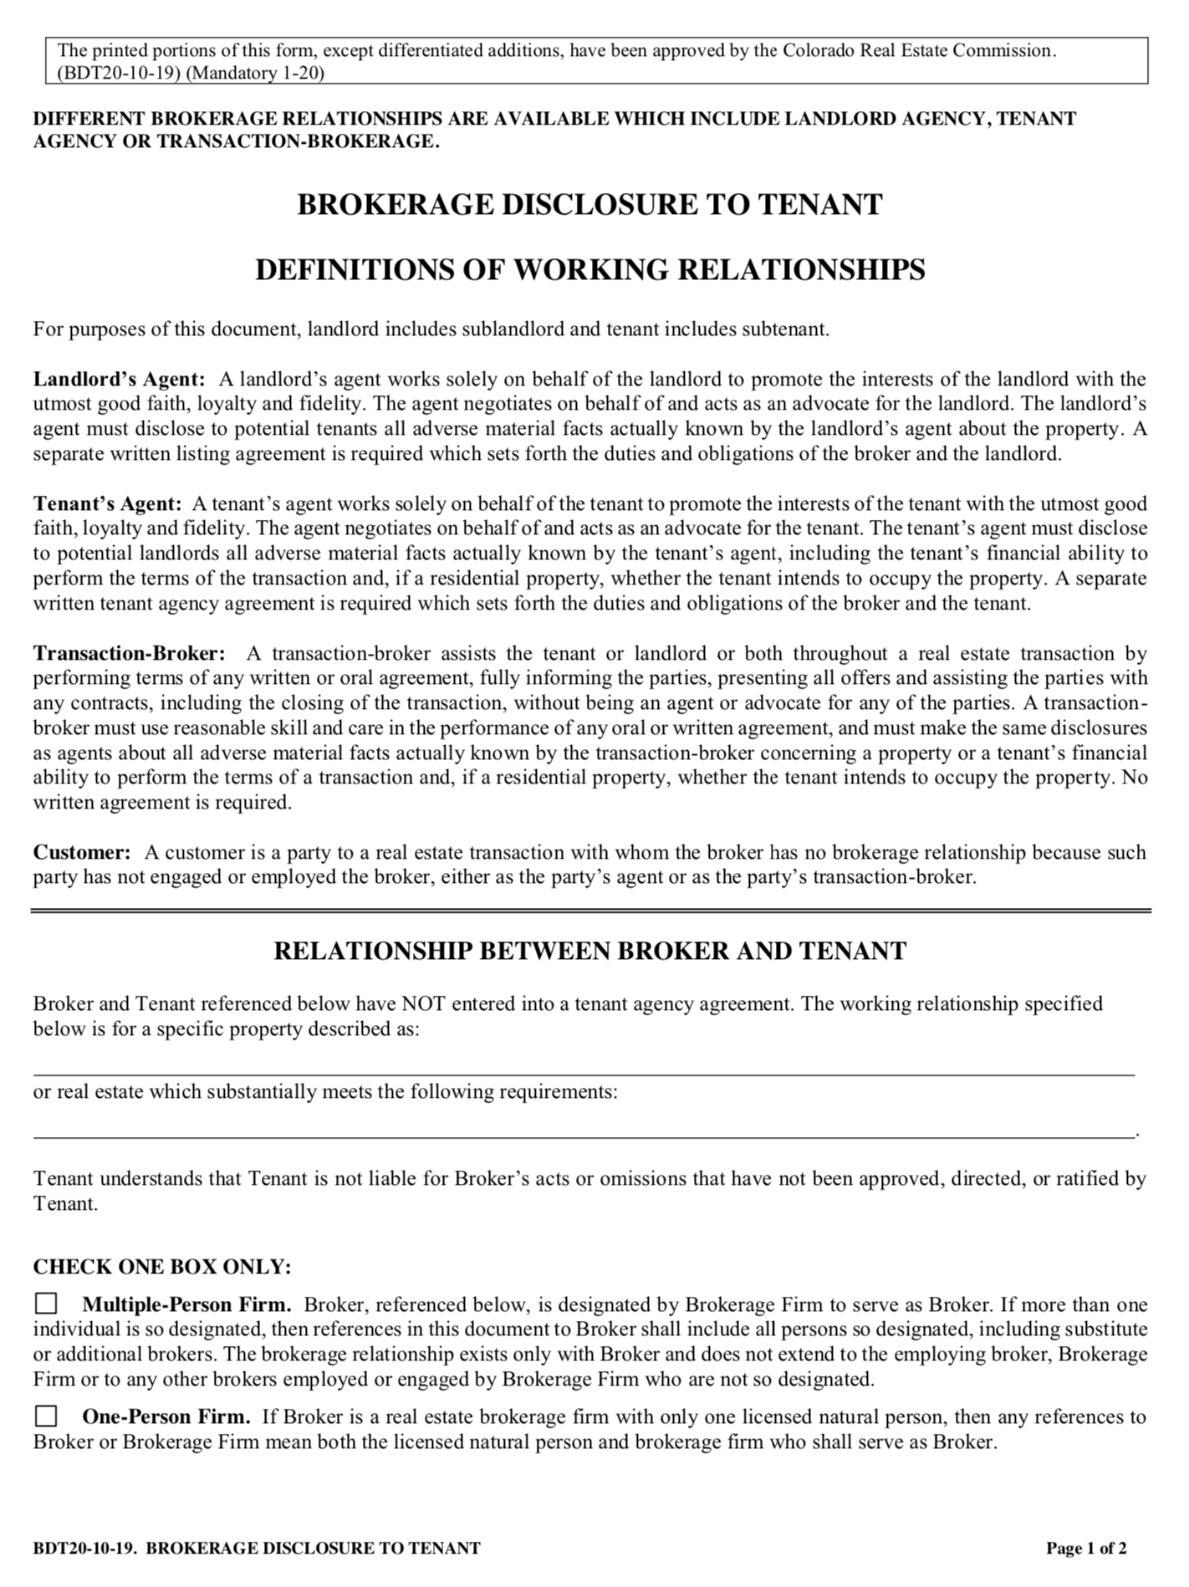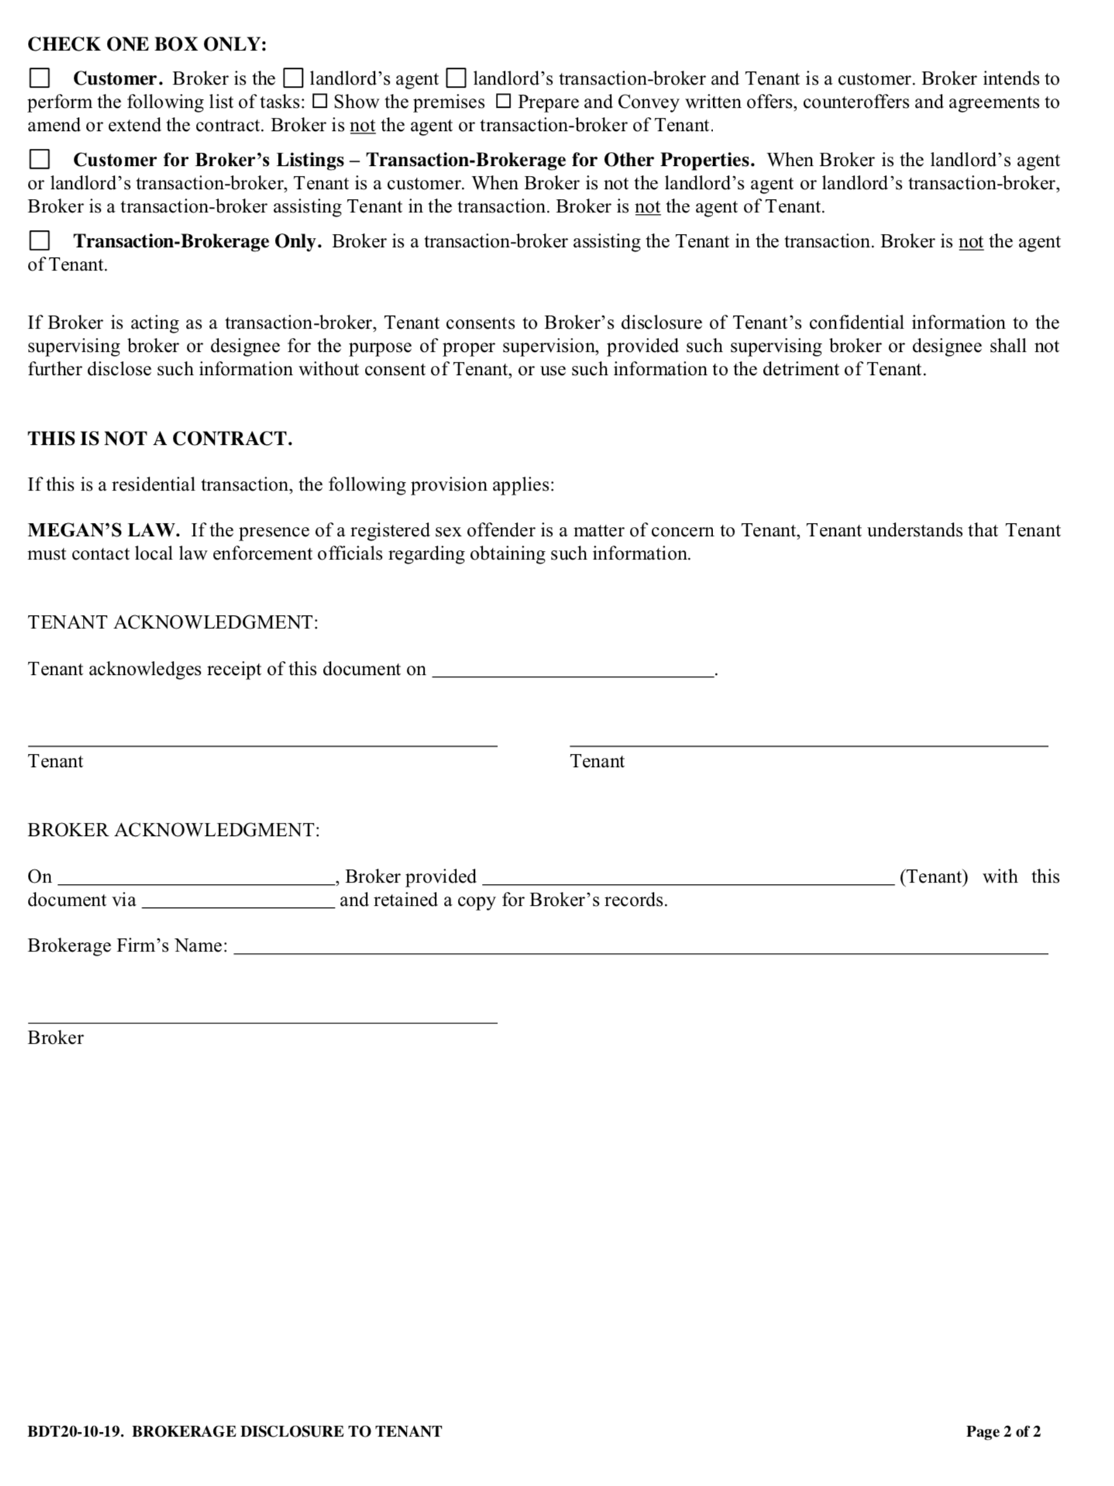
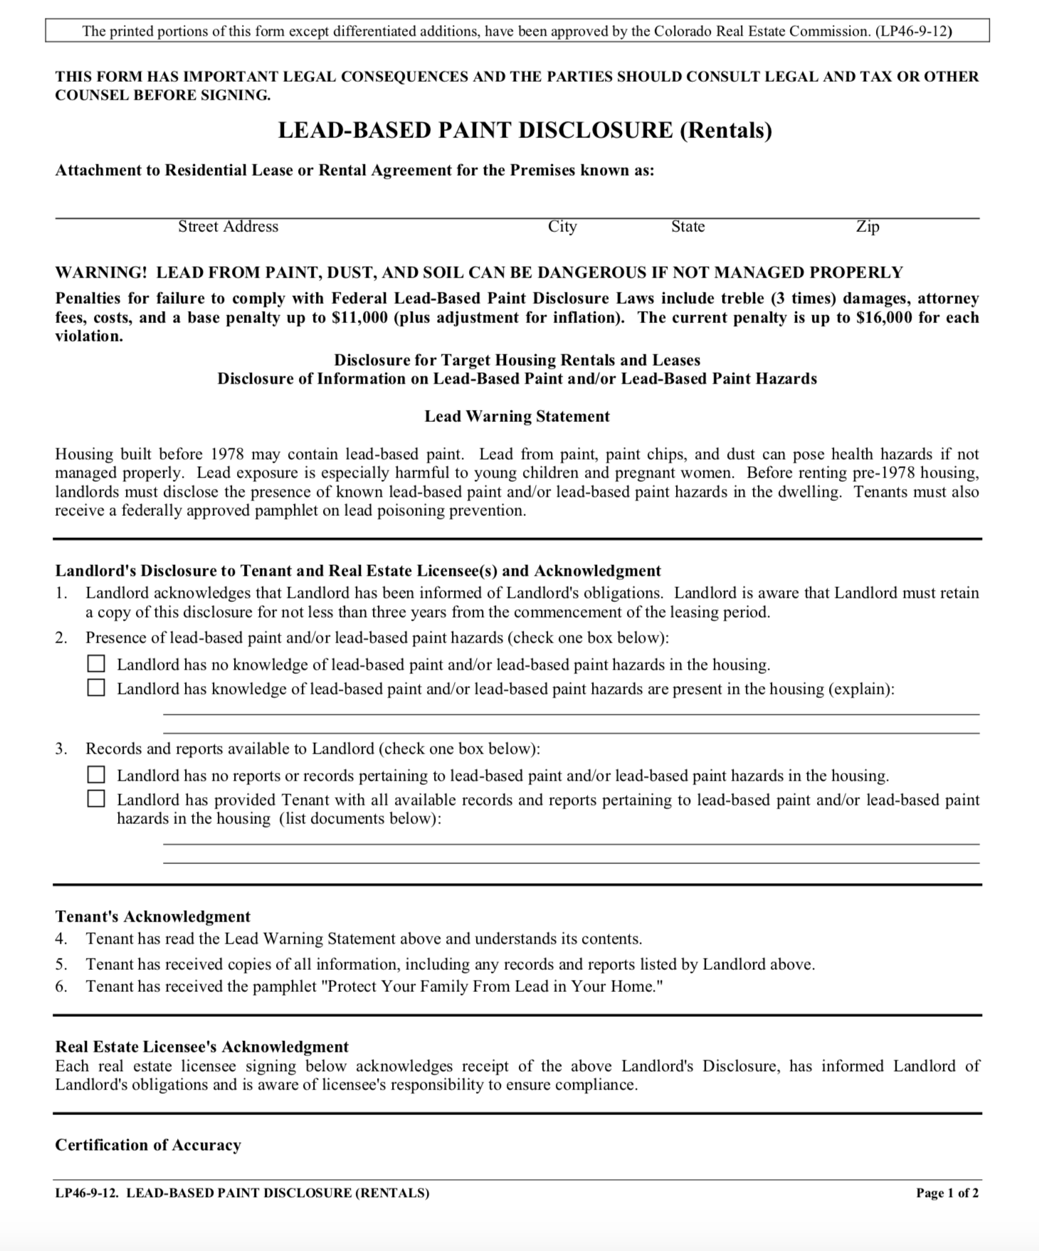

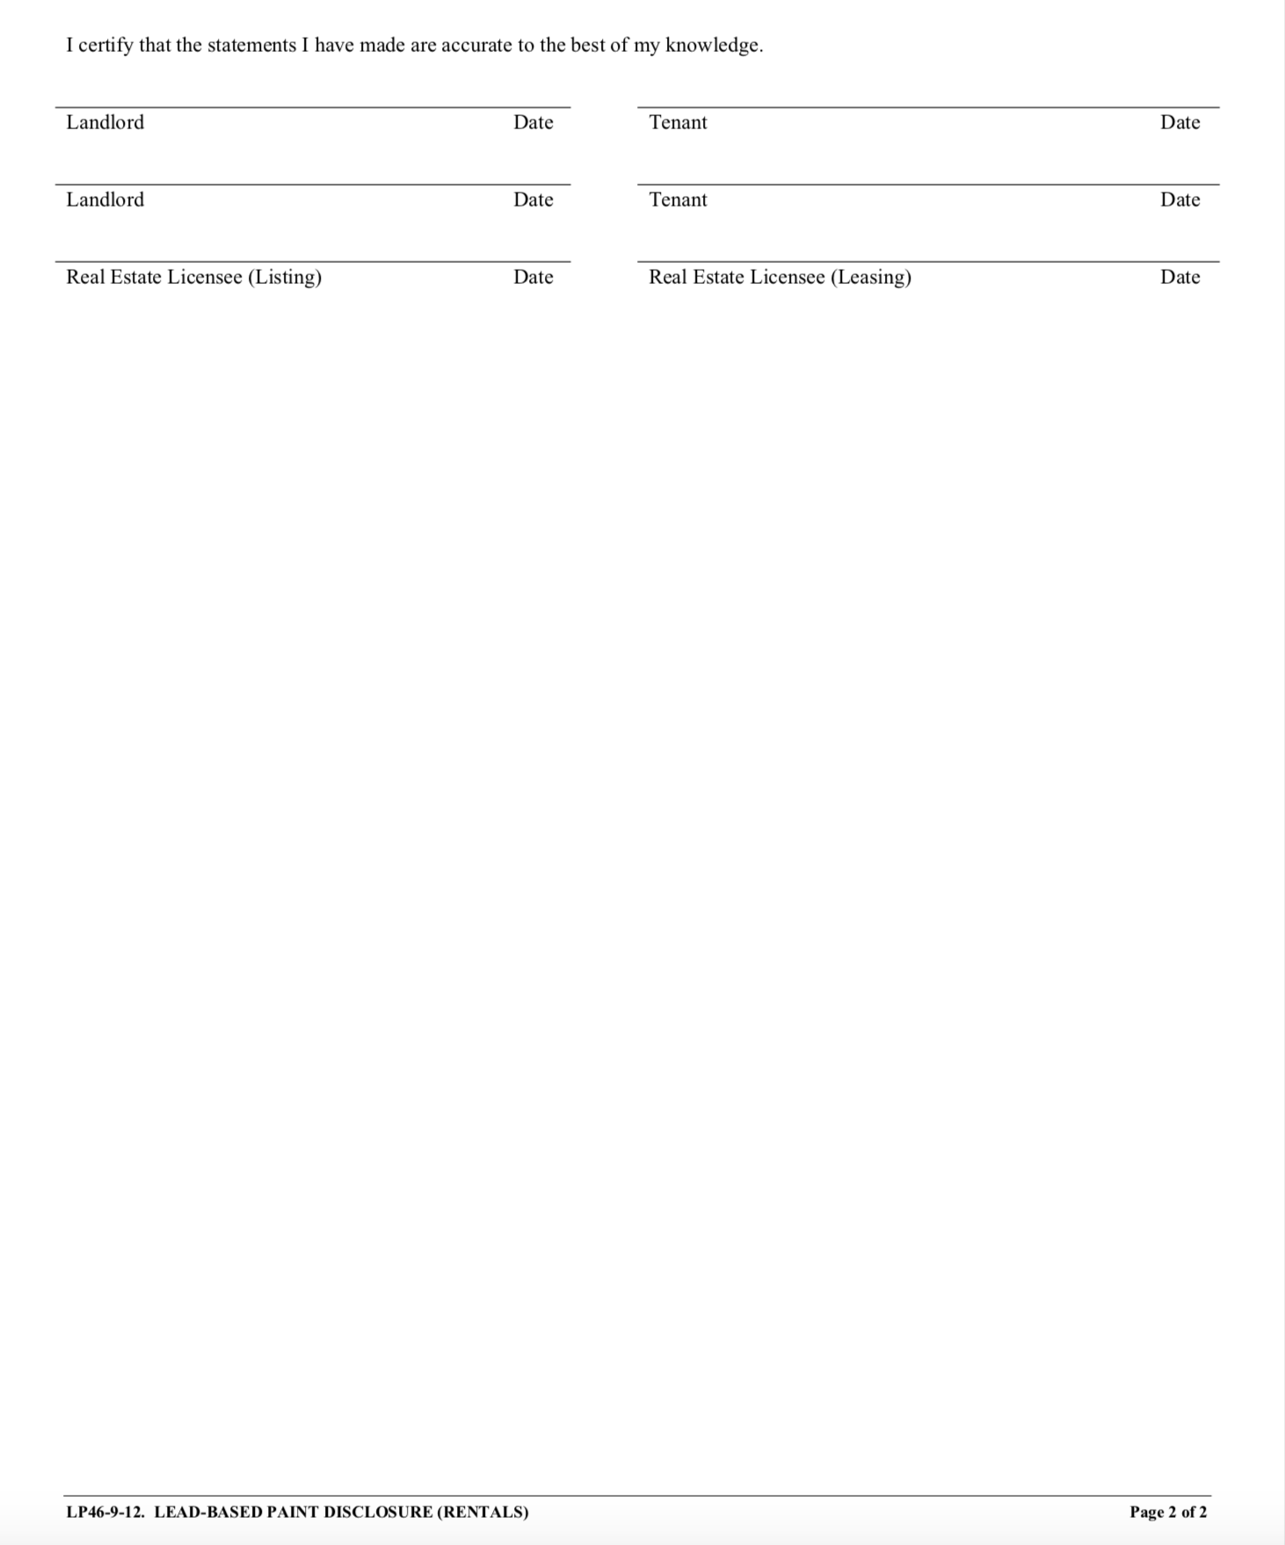


DAMAGE VS. WEAR & TEAR: What it means regarding your Security Deposit

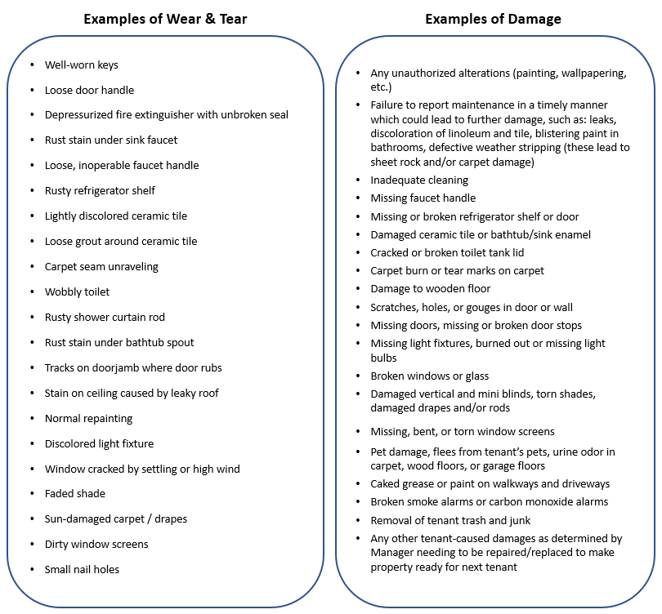

A security deposit is a sum of money held in trust during the course of a rental agreement to insure the Property Owner against default by the Tenant and for the cost of repair in relation to any damage that occurred by the action or inaction of the Tenant.

Tenant acknowledges that his/her Security Deposit, in accordance with Paragraph 3 of this document, may be used in part or in whole to cover the cost or repairs or maintenance for issues caused by the action or inaction of Tenant, beyond the scope of “normal wear and tear” as interpreted by Manager.

Tenant acknowledges that the above list is not comprehensive but provides reasonable examples of damage versus normal wear and tear.

Tenant’s signature hereon signifies that Tenant has received a copy of this agreement and fully understands all the provisions of this agreement. Tenant acknowledges that Tenant has the right to have an attorney review this agreement before it is signed.

Tenant 1

Name:

Permanent Mailing Address:

Primary Phone Number:

Date of Birth:

Driver’s License #:

Vehicles authorized for parking:

 | Make | Model | Color | License Plate # and State
1.
2.
3.
4.

SIGNATURE:

Tenant 2

Name:

Permanent Mailing Address:

Primary Phone Number:

Date of Birth:

Driver’s License #:

Vehicles authorized for parking:

 | Make | Model | Color | License Plate # and State
1.
2.
3.
4.

SIGNATURE:

Tenant 3

Name:

Permanent Mailing Address:

Primary Phone Number:

Date of Birth:

Driver’s License #:

Vehicles authorized for parking:

 | Make | Model | Color | License Plate # and State
1.
2.
3.
4.

SIGNATURE:

Tenant 4

Name:

Permanent Mailing Address:

Primary Phone Number:

Date of Birth:

Driver’s License #:

Vehicles authorized for parking:

 | Make | Model | Color | License Plate # and State
1.
2.
3.
4.

SIGNATURE:

Tenant 5

Name:

Permanent Mailing Address:

Primary Phone Number:

Date of Birth:

Driver’s License #:

Vehicles authorized for parking:

 | Make | Model | Color | License Plate # and State
1.
2.
3.
4.

SIGNATURE:

List all occupants under 18 or otherwise not listed as a Tenant above:

Manager:

