
Property Management Agreement
This Property Management Agreement has not been approved by the Colorado Real Estate Commission. This form was prepared in November of 2021 by the law firm of Gelman & Norberg, LLC, as legal counsel for Manager, and may not be altered other than by completing any blank spaces in the form.
This Property Management Agreement (“Agreement”) is entered into (Effective Date) by and between Whole Property Management, LLC (Manager), and Owner (provide full name):

Owner and Manager (who are sometimes jointly referred to below as the “parties” or individually as a “party”) hereto agree as follows:
EXCLUSIVE RIGHT TO LEASE AND MANAGE: The Owner hereby hires the Manager exclusively, giving the Manager the exclusive right to Lease and Manage under the terms and conditions as set forth in this Agreement for the Owner's property (“Property”) described as:
Address Pricing Plan

1. TERM:
A. This Agreement may be terminated immediately for any reason, with no notice period, by either party at any time by providing written notice to the other party. If Owner terminates this Agreement during the first 12 months from the Effective Date for any reason, Owner will be obligated to reimburse Manager within 30 days of the date the termination notice is provided to Manager for any amounts paid to Owner under the $5000 Pet Damage Guarantee or the $5000 Eviction Protection Guarantee and any listing expenses incurred by Manager (typically less than $500). Regardless of which party terminates this Agreement, upon termination, Manager will deliver to Owner all Property funds, after deducting all outstanding payables, including any amounts due to Manager. Manager may withhold funds after receiving the notice of termination to allow Manager to pay amounts owed under this Agreement and bills previously incurred, but not yet invoiced. Within 60 days after the end of the month in which the Agreement is terminated, the balance not applied toward amounts due will be paid to Owner.
B. Upon termination of this Agreement, Manager will deliver to Owner all Leases and other records in Manager’s possession pertaining to the operation of the Property, together with all keys, supplies, equipment or other items owned by Owner. Manager’s compensation will cease as of the termination date, except that Manager is entitled to compensation for services rendered before the termination date, inclusive of all leasing and services. Any services requested after termination, such as accounting or consulting, will be charged to Owner as additional services.
C. The parties’ representations and warranties, and all Agreement provisions requiring payment of attorney’s fees, indemnification, defense, reimbursement or pre-termination insurance, will survive termination of this Agreement.
2. MANAGEMENT COMPENSATION:
A. Owner agrees to pay Manager the fees set forth in “Schedule 1”. Owner acknowledges Manager may change pricing at any time at Manager’s discretion.
B. LEASE BREAK BY TENANT:
If tenant breaks the lease without complying with the early lease termination provision, Manager is nonetheless required to account for tenant’s security deposit. In this situation, Manager is permitted to use tenant’s security deposit to cover amounts owed by Tenant and costs related to Manager’s labor to prepare and re-lease the Property. Any security deposit balance left over after Manager’s expenses will be applied to unpaid rent or other damages owed to Owner. Manager will re-lease the property with no additional Leasing Fee to Owner.
C. EARLY LEASE TERMINATION BY TENANT: Pursuant to Manager’s standard Lease, the tenant is permitted to terminate the Lease early by paying an early termination fee in an amount equal to two months’ rent. If tenant terminates the Lease pursuant to that section of the Lease, Owner and Manager will split the early termination fee 50/50 and Manager will re-lease the Property free of charge to Owner. The portion paid to Manager is used to reimburse Manager for labor and time to re-lease the Property.
D. OTHER MANAGER COMPENSATION (not at the expense of the Owner): The Owner agrees that Manager may collect and retain the following fees from tenants as additional revenue to Manager: application fees, convenience fees (for online rent payments), maintenance charges, late or returned payment fees, or other fees paid by tenants to Manager.
E. LEASE PROCUREMENT: It is understood and agreed that the Manager is the sole procuring cause of any lease, written or oral that may be negotiated during the term of this Agreement, even if said lease may have been negotiated either directly or indirectly by the Owners themselves.
F. EXCLUSIONS: Except as otherwise stated in Schedule 1, this Agreement does not include preparing Property for sale or refinancing, construction or renovation management, modernization, fire or major damage restoration, rehabilitation, trips to the property outside of move-in and move-out inspections, representation before public agencies or in legal matters, debt collection, or laundry room or common area management (CAM) without a third party vendor. If Owner requests Manager to perform services not included in this Agreement, a fee shall be agreed upon before those services are performed, which will be no lower than ___________________.
3. MANAGEMENT AUTHORITY & RESPONSIBILITIES:
A. MARKETING, SHOWINGS, TENANT SCREENING: Manager may place a lockbox on the Property, coordinate cleanings, market and show Owner's property to prospective tenants, screen applicants and approve or deny applicants for Owner's property in accordance with Manager's rental application criteria and processes.
B. LEASE PREPARATION AND EXECUTION: Manager will negotiate and prepare new leases within the rental price parameters set by Owner, negotiate lease renewals and terminations of existing leases as deemed appropriate by Manager in its reasonable discretion. Manager is authorized, on behalf of Owner, to execute leases and lease renewals.
C. LEASE ENFORCEMENT: Manager has authority for full management and control of the Property, which includes, but is not limited to, the enforcement of lease provisions and terms, including termination of leases, whether or not tenants have signed Manager's lease or another form of lease. Manager has authority to collect all rents and other monies from tenants.
D. REPAIRS AND MAINTENANCE: Manager has full authority to coordinate and enter into contractual arrangements in the name of the Owner with independent contractors for any and all repair and maintenance services to be completed at the Property, based on Manager’s reasonable discretion. Owner agrees Manager shall pay said independent contractors for services performed with Owner's funds, whether said funds are collected from tenants or from the Owner. Owner acknowledges Manager will use Manager’s network of vendors for all repairs and maintenance. If Owner retains a home warranty and said company is unreasonably difficult to reach (e.g., long hold times, unreturned messages, general unresponsiveness, etc.), Manager is authorized to use Manager's vendors in lieu of the home warranty company. Manager will attempt to notify Owner via email or phone of any repair or maintenance item that is anticipated to be $500 or above, inclusive of labor and materials. Notwithstanding the previous sentence, in cases of time-sensitive issues, emergencies, or cases where delay will result in additional cost to Owner or additional damage to the Property, if Manager is unable to immediately get into contact with Owner, or if the exigency of the circumstance prevents Manager from immediately contacting Owner, Manager is authorized to make all repair and maintenance decisions that are reasonably necessary to protect or preserve Owner’s Property.
E. INSPECTIONS: Manager shall conduct or coordinate a Property inspection at the time of each tenant’s move-in and annually thereafter. Manager shall conduct or coordinate a move-out inspection at the time of each tenant’s departure. Periodic inspections during the lease term are performed by the Tenant using Manager’s inspection app, RentCheck. Additional inspections are available at Owner’s request and billed at Manager’s hourly rate, including travel to and from the Property.
F. SECURITY DEPOSIT DISPOSITION AND REPAIRS: Manager shall hold all security deposit funds in its trust account. Manager will solely determine whether or not use of security deposit funds for repairs or defaults is to be made.
G. RESERVE FUNDS: Manager will hold a reserve fund of $300 per property from Owner to cover maintenance/repair costs. These funds are used when rent funds are not available to cover said maintenance/repairs. These funds are Owner’s property and will be refunded should this Agreement be terminated in accordance with Section 1, above.
H. NOTICES AND LEGAL PROCEEDINGS: Manager has the authority to serve legal notices upon tenant(s) and to initiate and pursue legal proceedings in the name of the Owner, or in the name of the Manager, which include, but are not limited to, legal actions to evict tenants, recover rents and other amounts owed, and/or terminate tenancies.
I. ACCOUNTING: Manager shall pay third party vendors from Owner funds and Manager will provide online accounting statements available through Owner’s Owner Portal. If in the Manager's reasonable judgment, it may be necessary or proper to reserve or withhold Owner's funds to meet obligations which are or may become due and for which current income will not or may not be adequate, Manager may do so. All funds held by Manager will be in a banking institution of Manager’s choosing. Owner is not entitled to any interest that accrues on any accounts in which Owner’s money is held. Manager shall not be held liable in the event of a failure or bankruptcy of a depository.
J. OWNER DISBURSEMENTS: Manager will initiate a direct deposit payment to Owner of all remaining funds in Owner’s account after collection of management fees, maintenance, repairs, and other costs, on or before the 10th day of each month for the immediately preceding month. Owner understands that these payments typically take 1-2 business days to reflect on Owner’s bank account. If rent is paid late, so that it has not cleared Manager’s account by the 10th, Owner’s direct deposit payment will be delayed.
4. OWNER RESPONSIBILITIES:
A. RENT READY CONDITION: Owner agrees to deliver the Property to Manager in “rent ready” condition, meaning having been recently professionally deep cleaned, free of personal belongings, and in good repair.
B. COMMUNICATION: Owner agrees not to communicate with tenants via phone, email, text, fax, in-person, or by any other means, and that all communication regarding the Property, the tenant’s lease, or any other related matters, shall be conducted solely by and through Manager.
C. INDEMNITY: Owner agrees to indemnify, defend, and hold harmless Manager, and all of Manager’s managers, members, officers, directors, agents, representatives, attorneys, insurers, independent contractors, and employees, and each of their heirs, successors and assigns, from all damages liabilities, claims, demands, losses, liabilities, lawsuits, expenses, costs, and attorney fees which in any way arise from or relate to: (1) the management of the Property, except in the case of gross negligence or illegal act by the Manager; (2) Owner’s breach of any term, obligation, or representation as set forth in this Agreement; and (3) all liability for injuries or death to person or to property suffered or sustained by any person who is anywhere in, on, or about the Property, regardless of reason or cause, other than gross negligence or illegal act by the Manager. Owner’s obligations under this paragraph shall survive the termination of this Agreement, regardless of which party terminates this Agreement, or the circumstances under which this Agreement is terminated.
D. HOMEOWNER’S POLICY: Owner agrees to obtain and maintain in full force and effect, adequate property insurance against physical damage and against liability for loss, damage, or injury to the Property or persons which might arise out of the occupancy, management, operation, or maintenance of the Property. The minimum acceptable liability coverage is $300,000 per claim. Owner will then have Manager designated as an “additional insured” in the Owner’s insurance policy that covers the Property. The premiums and any deductible due and payable under the terms of any such Property insurance policy shall be at Owner’s sole expense. Owner shall furnish Manager with policy information prior to Manager marketing the Property and Owner also agrees to furnish Manager with any changes in policy and/or insurance carriers. Owner shall not allow this insurance policy to lapse or expire for any reason.
E. HABITABILITY: Owner agrees to maintain the property in a condition fit for human habitation in accordance with appliable laws.
F. SALES LISTINGS: Owner agrees not to list the Property for sale while engaged in the services of Manager, unless 30 days' notice to Manager is given. Owner hereby affirms the Property is not currently listed for sale.
G. HOMEOWNER’S ASSOCIATIONS: Manager shall not be liable for the failure of Owner or a tenant to comply with homeowners association (HOA) governance documents, including, but not limited to, the Covenants, Declaration, Articles of Incorporation, rules, regulations, restrictions, (collectively referred to as "CC&Rs"), or for any associated fees, costs, or penalties assessed for noncompliance with any CC&Rs. Owner further agrees to notify any governing HOA that Manager is the primary contact for communication regarding any violation concerns or service of any violation notices. Owner further agrees to include Manager on any mailings/notices sent by the HOA. HOA fines for tenant-caused issues will be passed along to tenants. HOA fines for Owner-caused issues will be the responsibility of Owner.
H. UTILITIES AND SERVICE CONTRACTS: Owner authorizes Manager to negotiate contracts for recurring and non-recurring items such as snow removal, lawn mowing, and trash removal and to enter into agreements for all necessary repairs, maintenance, and utility services. Owner agrees to have Landlord Agreements set up for utilities and to maintain service to each property. Owner authorizes Manager to execute contracts for utilities and services. Manager shall not be held liable for any injury, destruction, or damage to the Property, or injury, destruction, or damage to any neighboring property due to the failure of utility service being provided to the Property. Manager shall manage the utilities and coordinate the billing of such for Owner and the tenants as Manager deems most appropriate for the situation. Manager shall have authority to authorize installation or repair of wiring for tenant to acquire residential internet, cable, or phone services, which shall be paid for by Owner.
I. FINANCIAL RESPONSIBILITY OF OWNER: Owner shall be personally responsible for the payment for any expenses or other obligations incurred by Manager in the proper exercise of its authority and duties hereunder and shall be personally responsible for the payment to Manager of the amount of excess of expenditures over receipts.
5. OWNER REPRESENTATIONS:
A. Owner represents that, unless otherwise specified in writing, Owner is unaware of: (i) any notice of default affecting the Property from any current or former tenant, governmental agency, lender, or any other third-party; (ii) any delinquent amounts due under any loan secured by, or other obligation affecting, the Property; (iii) any bankruptcy, insolvency or similar proceeding affecting the Property or the Owner; and (iv) any litigation, arbitration, administrative action, government investigation, or other pending or threatened action that does or may affect the Property or Owner, and/or Owner’s ability to rent or transfer the Property. Owner shall promptly notify Manager in writing if Owner becomes aware of any of these items during the term of this Agreement.
B. Owner represents that any and all residential rental unit(s) contain all permits and government approvals needed to lawfully occupy and lease any such unit as a residential dwelling.
C. Owner represents that Owner has installed working and unexpired smoke alarms in each bedroom, in the hallway outside of each bedroom and on each floor whether or not a bedroom is located on the floor or as otherwise required by applicable laws. Owner represents that a working and unexpired Carbon Monoxide detector has been installed within 15 feet of each bedroom and on each floor regardless if a bedroom is present.
D. If Owner is a business entity, Owner represents that Owner is duly organized, validly existing and in good standing under the laws of the state in which the Property is located. The individual signing this Agreement on behalf of the Owner individually represents and warrants to Manager that he/she is duly authorized by the Owner to act on behalf of the Owner, to sign this Agreement, and to provide instructions and approvals (when necessary or appropriate) to Manager.
E. Owner has the power to enter into, execute and deliver this Agreement and to consummate the transactions contemplated hereby. The execution, delivery and performance of this Agreement and the consummation of the transactions contemplated hereby have been duly authorized by Owner, and Owner has taken all other actions required by law and its governing documents in order to consummate the transactions contemplated by this Agreement. Upon request, Owner shall deliver to Manager evidence of authority to act which may include applicable trust documents, or portion thereof, letters testamentary, court order, power of attorney, corporate or entity resolution, or formation documents of the business entity.
F. It is Owner’s full responsibility to disclose in writing if any of the following are known to be present on the subject Property: Lead-based paint, mold, asbestos, radon gas, and possible methamphetamine contamination. Owner further agrees to notify Manager, prior to the execution of this Agreement, if the property is delinquent on any mortgage payments or if the possibility exists that the Property may be at risk for foreclosure due to non-payment.
G. Owner affirms that the Property is in full compliance with Colorado habitability and landlord/tenant laws. Owner shall be financially responsible for all costs and expenses incurred by Manager to keep the Property in a habitable condition.
H. Colorado law requires a property manager to disclose to any prospective tenant all adverse material facts actually known by such manager including but not limited to adverse material facts pertaining to the title to the Property, the physical condition of the Property, any material defects in the property, and any environmental hazards affecting the property required by law to be disclosed. These types of disclosures may include such matters as structural defects, soil conditions, violations of health, zoning or building laws, and nonconforming uses and zoning variances. Owner agrees that any tenant may have the Property and Inclusions inspected and authorizes Manager to disclose any facts actually known by Manager about the Property. Manager shall not be liable to tenant(s) for any violation of these laws, unless such violations are caused by gross negligence of Manager.
6. MISCELLANEOUS
A. For purposes of this Agreement all notices required herein shall be deemed to have been served upon the other party when e-mailed or otherwise mailed to the following addresses or to such other addresses as shall be changed in writing, properly notifying the other party. Notice shall be provided to each respective party at the address or e-mail address listed in the signature line at the end of this Agreement.
B. By signing this Agreement, Owner acknowledges and asserts that Owner has no knowledge of any environmental hazards related to property and agrees that if any environmental hazards arise that the Owner takes full responsibility of any cost in removing such hazards and responding to any claims or demands of any tenant, former tenant, governmental agency, or other third-party.
C. Manager assumes no responsibility for other services than agreed to unless specified in the terms of this Agreement or in writing at a later date.
D. This Agreement contains the entire agreement and the full understanding between the parties, and supersedes all prior discussions or negotiations, and there are no further understandings or agreements, oral or written, relating to the subject matter of this Agreement. For purposes of this paragraph, the Agreement includes all of the following documents: (1) Property Management Agreement; (2) Owner Questionnaire; (3) Brokerage Disclosure to Landlord Definitions of Working Relationships; (4) Lead-Based Paint Disclosure; (5) Schedule 1 – Fees; (6) Terms and Conditions: WholePM Guarantees; and (7) Authorization Agreement for Direct Deposit (ACH Credits). Each of the above-listed documents are hereby incorporated into and made a part of this Agreement.

E. This Agreement shall not be assignable by Owner without the prior written consent of Manager. This Agreement is assignable by Manager without the prior written consent of Owner.

F. If any provision of this Agreement shall be deemed invalid, illegal, or unenforceable, the validity, legality and enforceability of the remaining provisions of this Agreement shall not be affected or impaired.

G. The failure of either party to enforce the terms of this Agreement shall not be deemed as a waiver on the part of that party to subsequently insist on strict enforcement of the terms of this Agreement.

H. Any amendment to this Agreement must be in writing and signed by all parties to this Agreement.

I. Paragraph headings are for reference purposes only and do not affect the interpretation of this Agreement.

J. This Agreement may be executed in counterparts, with each counterpart being an original document, and all counterparts together constituting a single agreement. Fax, electronic, and scanned signatures are binding on the Parties.

K. In the event of a dispute between the parties which in any way arises from or relates to this Agreement, each party shall pay his/her/its own attorney fees and costs. The prevailing party in any litigation shall not be awarded his/her/its reasonable attorney fees and costs.

L. This Agreement shall be governed by, interpreted, and enforced in accordance with the laws of the State of Colorado, regardless of any choice of laws provisions of the State of Colorado. Venue for any lawsuit that relates to or arises from this Agreement shall be a court of competent jurisdiction in the county in which the property is located. IN THE EVENT OF ANY LAWSUIT THAT RELATES TO OR ARISES FROM THIS AGREEMENT, THE PARTIES KNOWINGLY AND VOLUNTARILY WAIVE THEIR RIGHT TO A JURY TRIAL.

Addenda to Management Agreement:


Owner Questionnaire
- On what date will the property be rent-ready? (vacant, empty of all items, in good repair, and professionally deep cleaned, unless otherwise discussed and agreed)

- What utilities are paid through your HOA fee (if applicable) or property taxes? Tenant will pay all other utilities.

- Are tenants authorized to have pets on the property?

- If yes, may we allow dogs, cats, or either? Our default maximum is 2 pets total, with size and breed approval by WholePM.

- Will a washer and dryer be provided? This is highly recommended.

- What day(s) does trash and recycling service come to the property?

- Where is the main water shut-off located?

- Where is the sprinkler system water shut off located, if present?

- HOA/Building manager company name and contact info (if applicable):

- Current Access Information, if applicable:

  - Building Access Code:
  - Front Door Access Code:
  - Lockbox Access Code:
  - Garage Access Code:
  - Alarm Code:
  - Gate Access Code:
  - Other:

- Electricity Provider:

- Water Provider:

- Trash Collection Provider:

- Mechanical Information:

  - Does the property have Central A/C?
  - Heater Type (furnace, baseboard heaters, boiler):
  - Location of furnace:
  - Location of furnace filter:
  - Size of furnace filter:

- Parking Information:
  - Parking Type (garage, carport, driveway, on-street, dirt lot):
  - Number of covered spaces:
  - If this is a common garage or lot, how many RESERVED spaces?
  - Parking permits required?

- Mailbox location and number (if not obvious):

- Is the home or any parts therein under warranty? If so, provide warranty company and policy number:

- Does the property have a sprinkler system that WholePM should winterize and activate? Answer NO if your HOA does this. WholePM charges a $25 fee plus vendor cost for this service.

- Does the property have a Swamp Cooler / Evaporative Cooler that WholePM should winterize and activate? WholePM charges a $25 fee plus vendor cost for this service.

- Is lawn care and snow removal handled by an HOA? (If not, tenant will be responsible)

- What is the bedroom count, bathroom count, and total finished square footage?

- If your property’s electric and gas service is from Xcel Energy, complete the Automatic Turn On form using the link below. This automatically reverts the Xcel Energy bill back into your name during periods of vacancy between Tenants. We will take care of getting this switched into the name of the Tenant prior to their move-in.
Name and phone number of Property Manager to use on this form: Whole Property Management, (720) 737-1373
https://cloud.marketing.xcelenergy.com/ato
I confirm that I have completed this step (required if your property is served by Xcel Energy)
This step is not applicable to me

- Other information you’d like to provide to Manager:

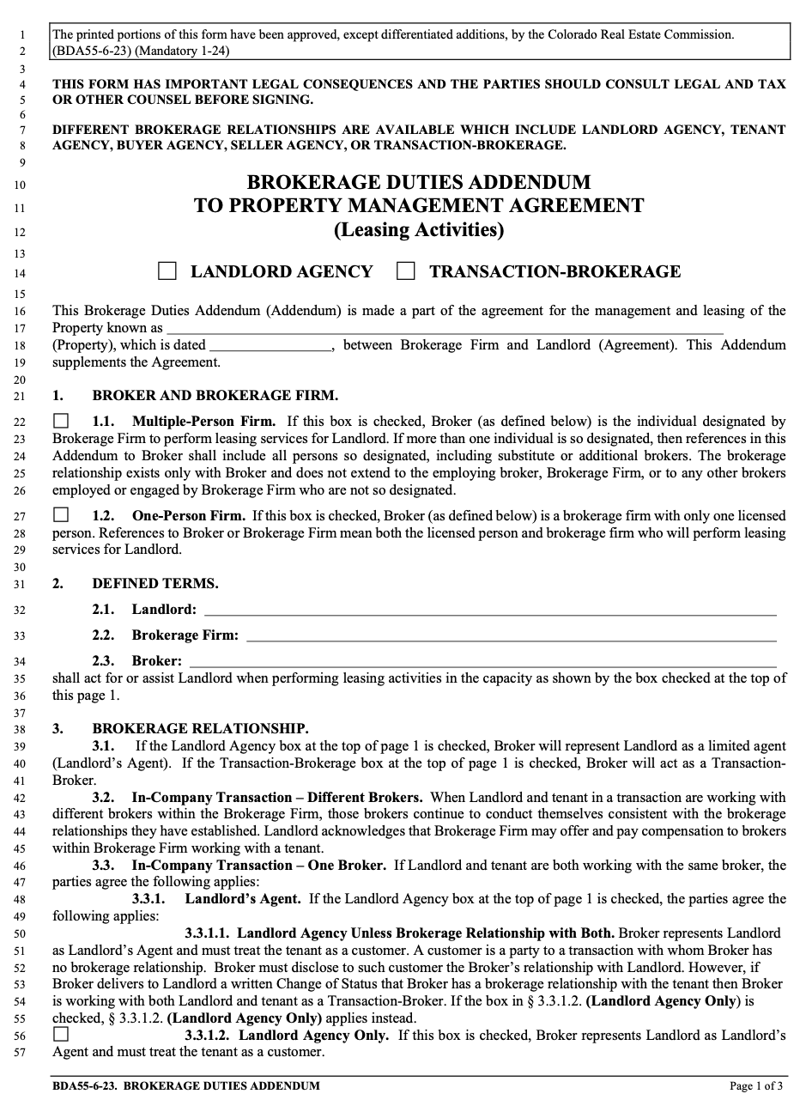
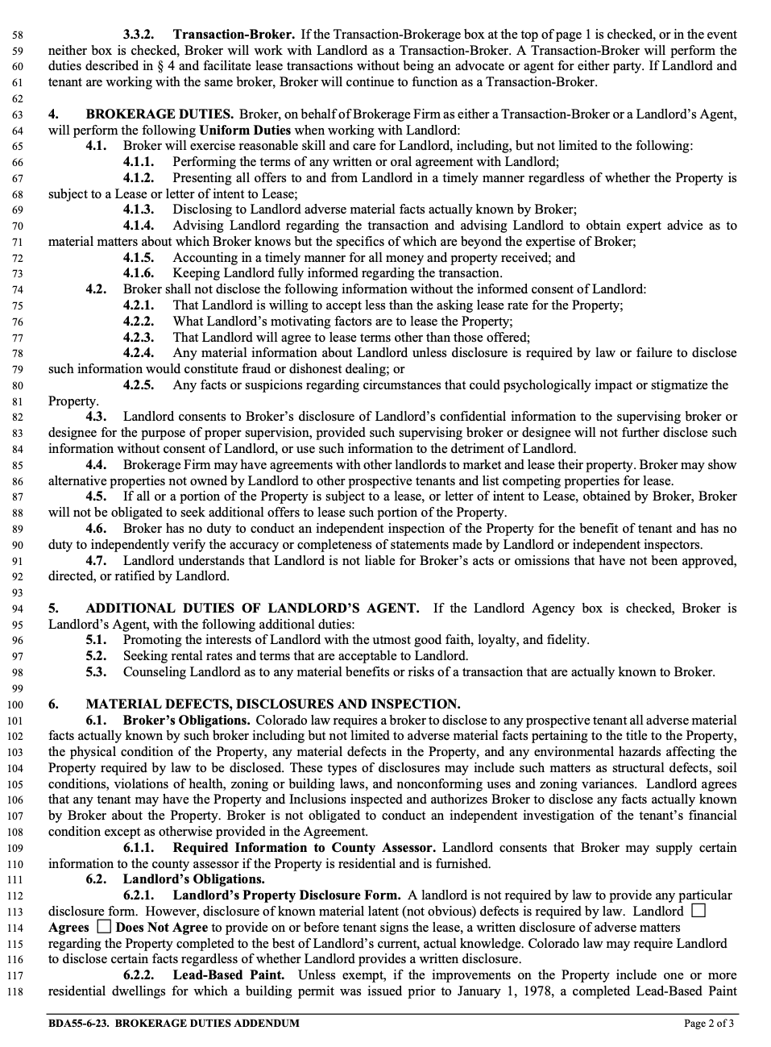
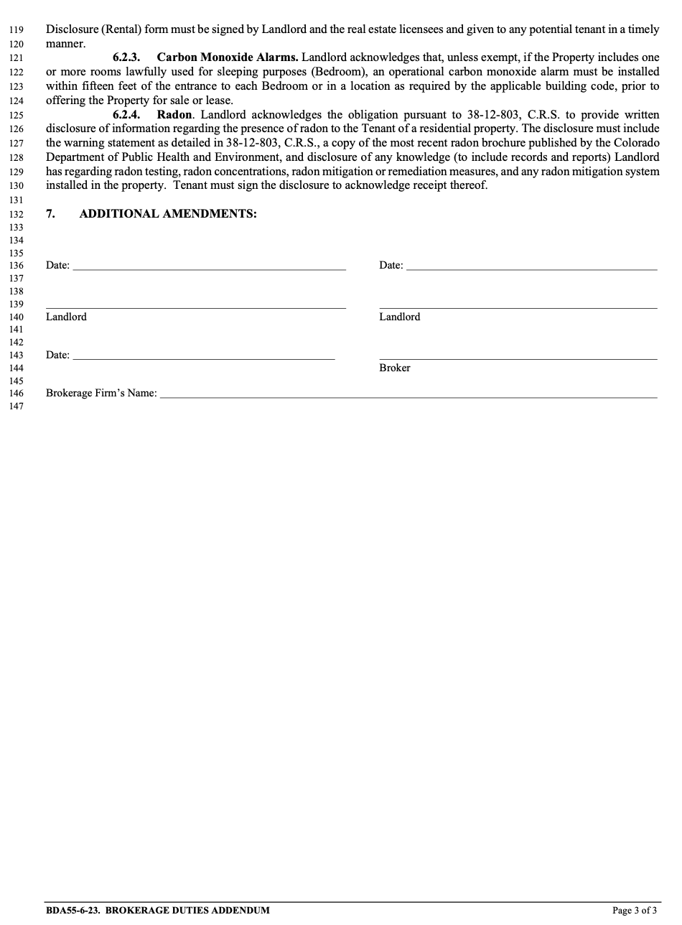
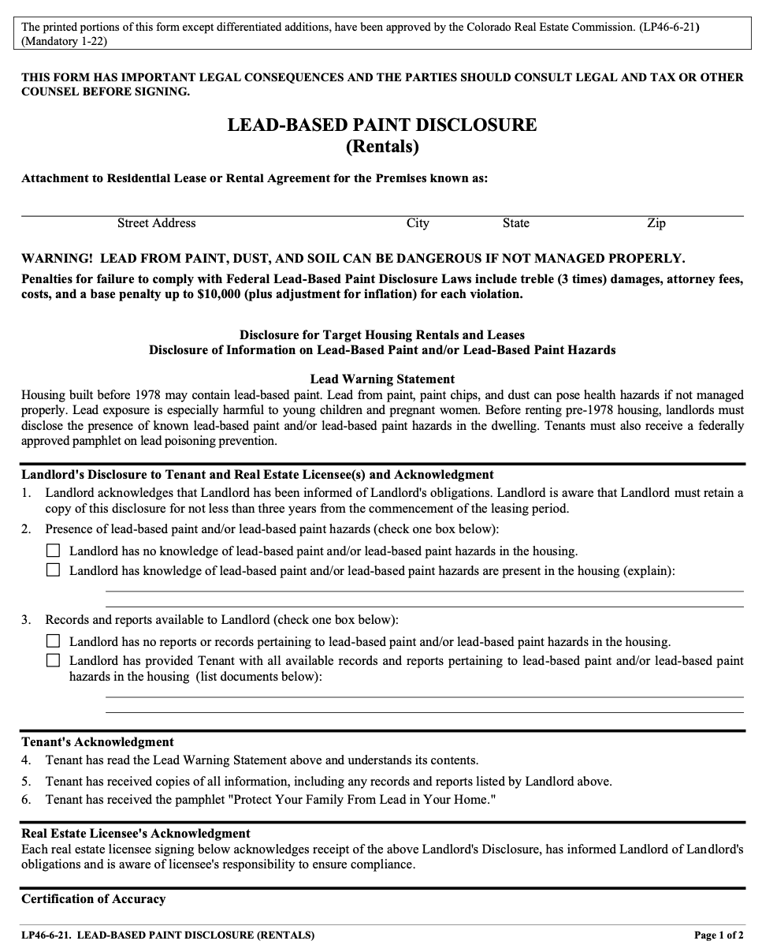
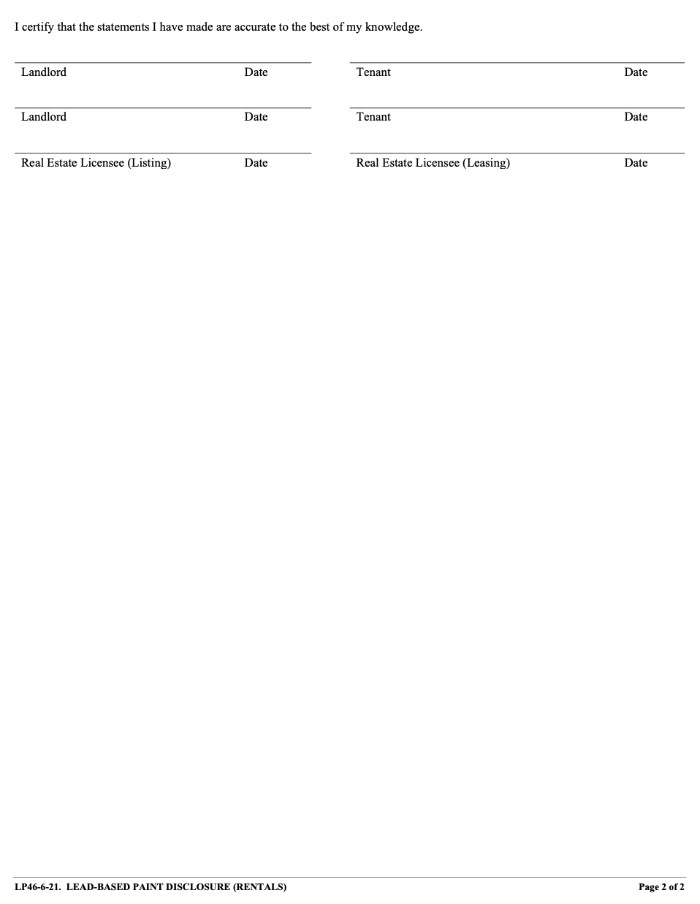
SCHEDULE 1 – FEES
Core Plus Whole 9 Yards
Monthly Fee
Leasing Fee
Lease Renewal Fee
Tenant Warranty
Free Cancellation
Free Move-In, Move-Out & Annual Inspections
$5000 Eviction Protection
$5000 Pet Damage Protection

Pricing Plan: Owner has selected the pricing plan reflected on Page 1 of this Agreement and agrees to pay Manager the amounts set forth above for the corresponding plan.
Monthly Fee: The monthly fee is the amount charged per property or unit for ongoing management. For any partial months, the management fee is not prorated.
Leasing Fee: The above percentage of one full month’s rent for securing a new tenant.
Renewal Fee: The above amount for each lease that is renewed or extended.
Pet Damage Protection: This guarantee, if included in the selected package, protects a property owner’s rental asset from unforeseen pet damage when a WholePM-placed resident moves out. If the pet of a resident that was screened and placed by WholePM is responsible for property damage beyond normal wear and tear that is above the amount of the security deposit and is not insurance-covered, WholePM will cover the difference up to $5,000.* More information about this is provided below.
Eviction Protection Plan: This guarantee, if included in the selected package, protects a property owner when a resident is unable to pay rent. If a WholePM-placed resident fails to pay rent and an eviction is required, WholePM will cover the court costs and legal fees up to $5,000.* More information about this is provided below.

Schedule 2: Fee & Markup Disclosure

Fees & Markups Charged to Owner:
1) Monthly Management Fee (according to selected pricing plan)
2) Leasing Fee (according to selected pricing plan)
3) Lease Renewal Fee (according to selected pricing plan)
4) Optional sprinkler system activation/deactivation and evaporative cooler activation/deactivation services (WholePM adds a $25 markup to the invoiced cost from our vendor)
5) ___________ Tax Preparation Fee charged each January for the preparation and filing of Owner’s Form 1099-MISC
7) Any excluded services (See Section 2, Paragraph F) will be charged to Owner at an agreed-upon rate which will be no lower than $100 per hour.

Fees & Markups Charged to Tenant:
1) Tenant Leasing Fee ___________ charged at the time of initial lease signing to defray the cost of showing the property, screening applications, preparing and executing the lease, and coordinating move in
2) ___________ Tenant Lease Renewal Fee charged at the time a lease is renewed to defray the cost of negotiating and executing a new lease
3) __________ Convenience Fee for online EFT payments paid through Manager’s online tenant portal to defray the cost Manager is charged by the payment processor for each incoming EFT payment
4) Fee for tenant payments made by credit card: _______________________________________________________________
5) __________ Tenant Move Out Fee charged at the time of move out to defray the cost of move-out coordination, inspections, and maintenance related to turning over the Property
6) ___________ Pet Fee if the Tenant’s pet(s) are approved to occupy the property to defray Manager’s additional labor in screening and approving pets and potential additional labor at move out to prepare the property for re-leasing
7) Manager’s portion of the Early Termination Fee paid by Tenant as described in Section 2 Paragraph C.
8) Resident Benefit Package (_____________________) which provides renter’s insurance, credit reporting, other renter benefits, and defrays Managers cost to provide a manned 24/7 emergency maintenance hotline.

Terms and Conditions: WholePM Guarantees
Pet Damage Protection
- If the pet of a resident that was screened and placed by WholePM is responsible for property damage after move-out that is beyond normal wear and tear, and the cost to repair the damage exceeds the security deposit, WholePM will cover the cost of the damage that exceeds the security deposit in an amount up to $5,000. WholePM’s payment under this agreement is for items not covered or denied by Owner’s homeowner’s insurance policy and Tenant’s renter’s liability insurance policy.
- A resident screened and placed by WholePM means that the resident’s application was approved pursuant to WholePM’s standard screening criteria and the amount of the security deposit was determined by WholePM.
- Payment under the Pet Damage Protection guarantee will occur after submission of final repair invoices and WholePM’s confirmation that the repairs were not for normal wear and tear.
- WholePM’s payment under this guarantee will not waive WholePM’s right to pursue such amounts directly from the tenant.
- WholePM shall have repairs performed under this program using vendors of WholePM’s choosing.
Eviction Protection Plan
- If a resident that was screened and placed by WholePM fails to pay rent and an eviction is required, WholePM will cover the court costs and legal fees incurred up to $5,000. This does not include the cost to post/serve demand notices to Tenant.
- WholePM’s payment under this guarantee will not waive WholePM’s right to pursue such amounts directly from the Tenant.
The guarantees and plans listed above are available to property owners that have selected a pricing plan that includes the specific guarantee or plan. Each guarantee and plan will terminate, along with all obligations, upon termination of the property management agreement between WholePM and the property owner. WholePM may modify the terms and conditions of each guarantee or plan at any time.
Force Majeure. WholePM shall not be responsible or liable for payment under the guarantees for any property damage or failure or delay in the performance a resident’s lease obligations to the extent they arise out of or are caused, directly or indirectly, by forces beyond WholePM or its resident’s control, including, without limitation, strikes, work stoppages, accidents, acts of war, terrorism or threats of terrorism, civil or military disturbances, nuclear or natural catastrophes, fire, flooding, wind, disease or medical epidemics or outbreaks, or other acts of God.

AUTHORIZATION AGREEMENT FOR DIRECT DEPOSIT (ACH CREDITS)
I hereby authorize Whole Property Management, LLC, “Manager”, to deposit funds to the checking account indicated below at the depository financial institution named below, hereinafter called DEPOSITORY.

BANK NAME
ROUTING NUMBER ACCOUNT NUMBER

This authorization is to remain in full force and effect until Manager has received written notification from Owner of its termination in such time and in such manner as to afford Manager and DEPOSITORY a reasonable opportunity to act on it.
IMPORTANT: Owner alone is responsible for ensuring the above information is correct. Owner acknowledges and agrees that if funds are sent by Manager to the account listed above, and above account information is incorrect, Manager cannot recover or refund said funds.

Owner Signature:
Date:
Owner Name:
Address:
Phone:
Email:
Owner Emergency Contact (name, phone, and email):

__________________________________________________________________________________________________
Real Estate Broker: James T. Howell, License # ER.100070592
Whole Property Management, License #: EC.100080628
Signature:
Date:
Phone: (720) 737-1373
Email: info@wholepm.com
